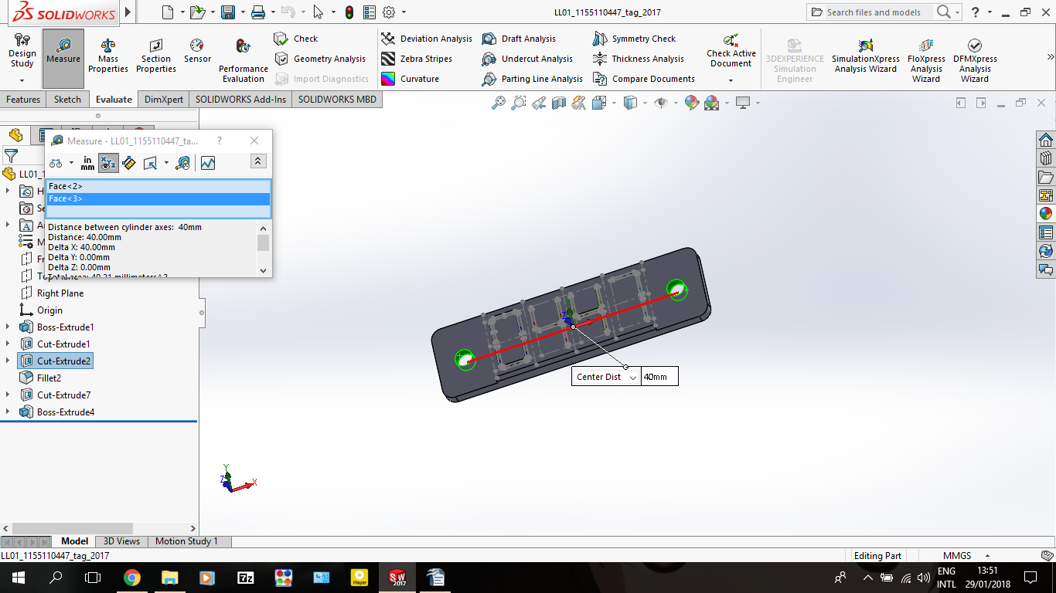
ENGG1100 Introduction to Engineering Design I
Engineering Faculty
The Chinese University of Hong Kong
Homework 1: Computer Aided Design Using SolidWorks

Lab Session:
Name:
SID:

Section I
Complete the following table with screenshots of the tag that you have drawn.
Width of tag: | Height of tag: |  | Thickness of tag:
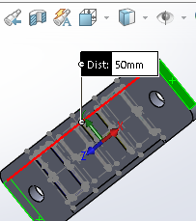 | 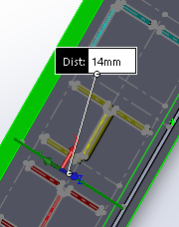 |  | 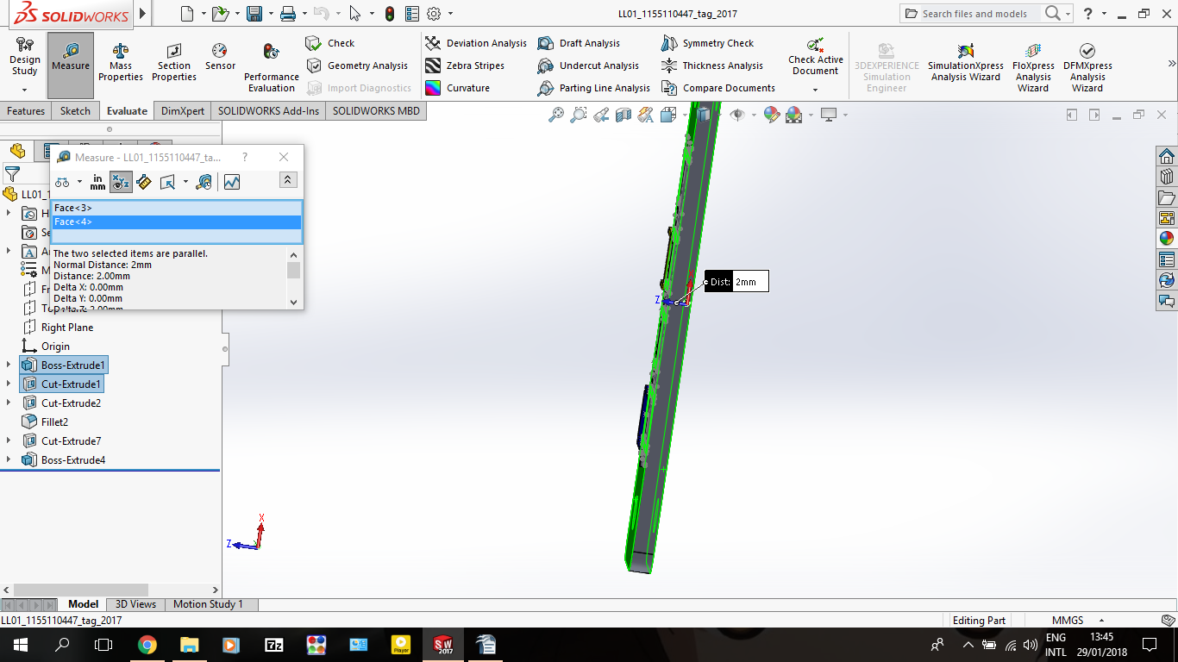
Fillet: | Hole diameter: |  | Distance between the holes:
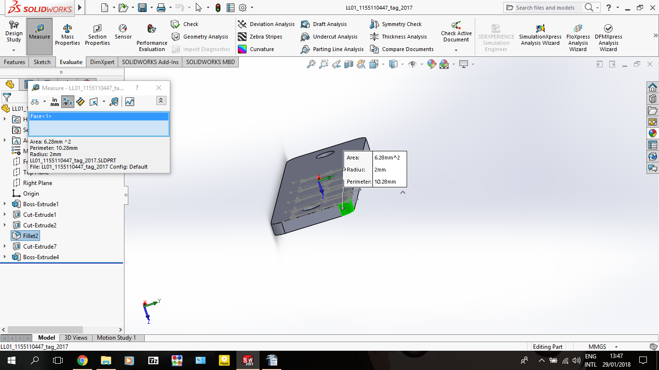 | 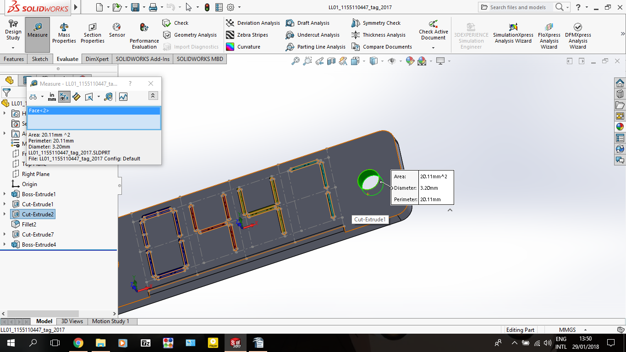
Width of bar: | Height of bar: |  | Thickness of bar:
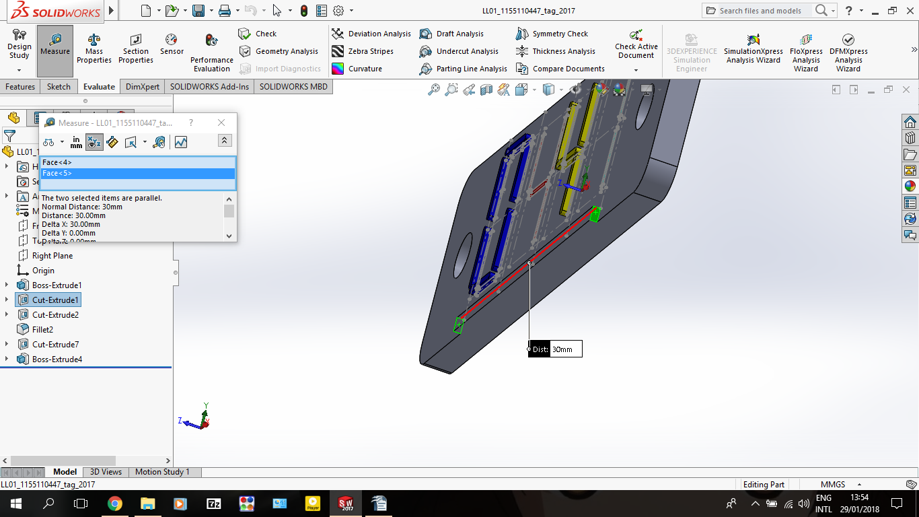 | 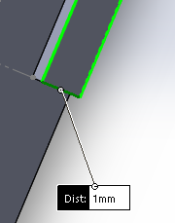 |  | 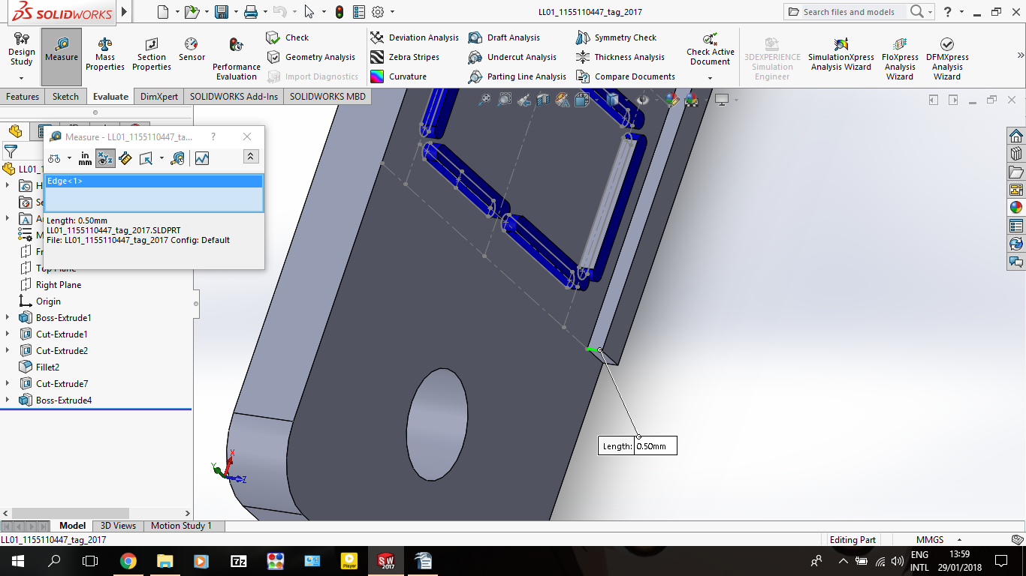
Isometric view of your tag:
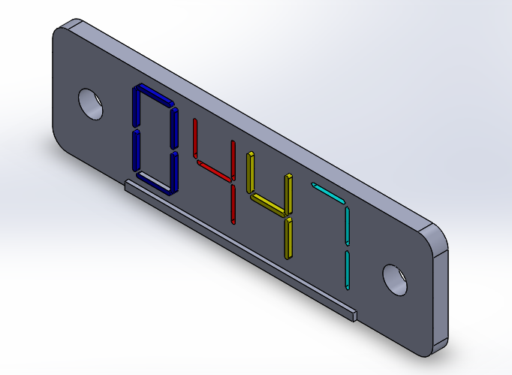

Section II
Complete the following table with the screenshots of your assembly file.
Concentric 1: | Concentric 2:
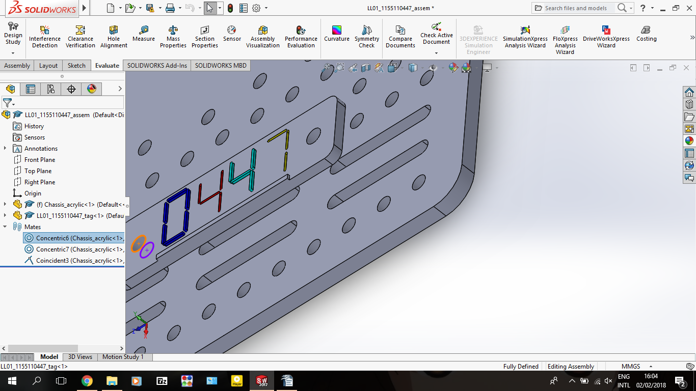 | 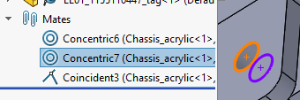
Coincident: | Isometric view of the assembly:
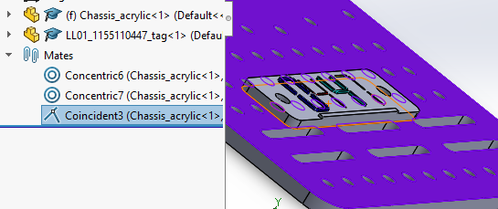 | 